**Regression Model to predict Car Sales**

**Business Problem**

An Automotive industry group keeps track of the sales for a variety of personal cars. In an effort to be able to identify over- and underperforming Car models, I want to establish a relationship between vehicle sales and vehicle characteristics. Information concerning different manufacturer and models of cars is contained in car_sales.csv

**What Drives Car Sales?**

**Null Hypothesis:** There is no significant difference in the Car Sales due to the Price in thousands Engine size, Length, Fuel efficiency, Vehicle type etc.

**Alternate Hypothesis:** There is significant difference in the Car Sales due to the Price_in_thousands Engine size, Length, Fuel efficiency, Vehicle type etc.

**Variables:**

Manufacturer

Model

Sales_in_thousands

year_resale_value

Vehicle_type

Price_in_thousands

Engine_size

Horsepower

Wheelbase

Width

Length

Curb_weight

Fuel_capacity

Fuel_efficiency

Latest_Launch

Power_perf_factor

**Histogram of Dependent variable (Sales_in_thousands)**

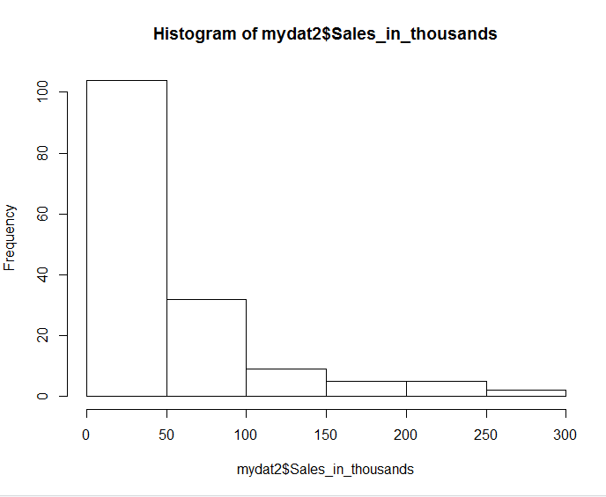

Histogram of Dependent variable without transformation.(not normal)

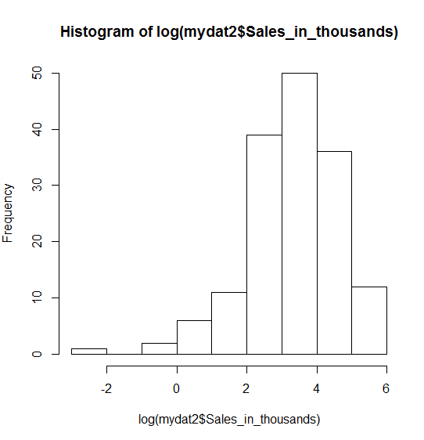

Histogram(Distribution) of Dependent variable with natural log transformation.(Behavior is more normal compared to actual distribution). Dependent variable into natural log transformed variable makes improvement in the model.

**Scatter plot to check for Multicollinearity**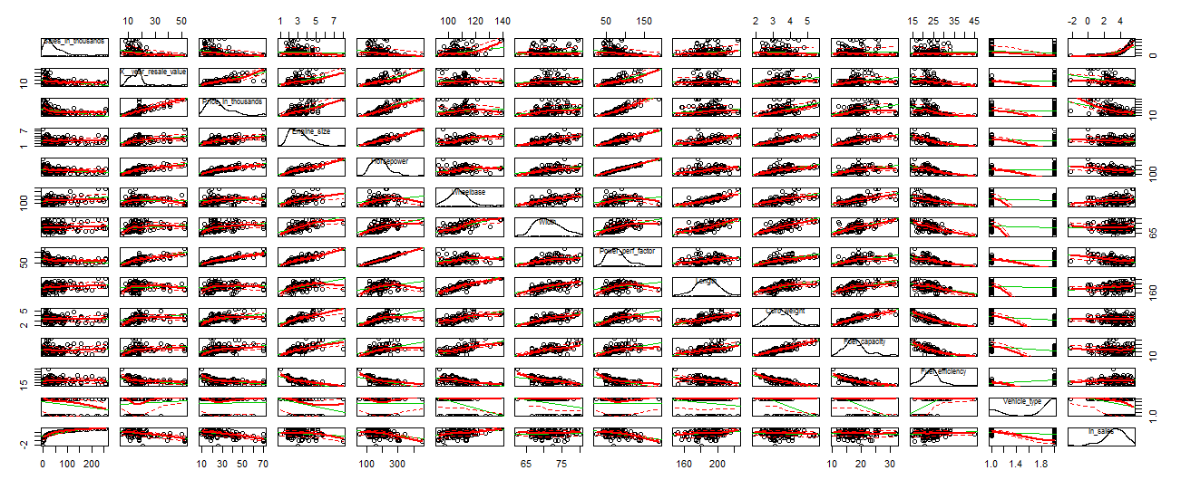

The variables which are showing completely random pattern are of no use for the model. The variables which are showing some kind of trend will be useful for our model. From this graph we can understand the histogram for each variable and choose the appropriate variable during refinement.

**Correlation Matrix Plotted graphically(**Before Refinement)

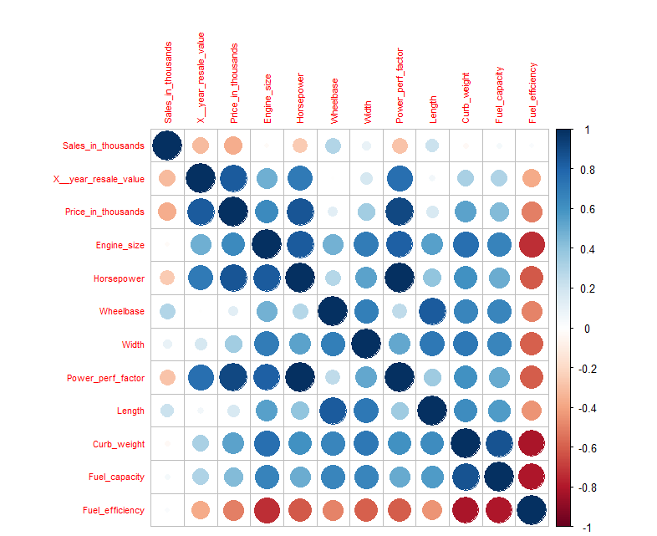

Deeper blue- correlation on positive side (Highly correlated).

Deeper red - correlation on negative side.

**StepAIC (Akaike Information Criteria)** for multicollinearity

**Final Model:**

fit3<-lm(ln_sales ~ Price_in_thousands + Engine_size + Length + Fuel_efficiency + Vehicle_type, data = mydat2)

summary(fit3)

Min 1Q Median 3Q Max

-4.8655 -0.4920 0.0585 0.6438 1.9195

**Coefficients:**

Estimate Std. Error t value Pr(>|t|)

(Intercept) -2.665274 1.750235 -1.523 0.129898

Price_in_thousands -0.054009 0.008564 -6.307 2.99e-09 ***

Engine_size 0.232789 0.136715 1.703 0.090675 .

Length 0.028122 0.007352 3.825 0.000191 ***

Fuel_efficiency 0.090831 0.035328 2.571 0.011104 *

Vehicle_typePassenger -0.978133 0.246877 -3.962 0.000114 ***

---

Signif. codes: 0 ‘***’ 0.001 ‘**’ 0.01 ‘*’ 0.05 ‘.’ 0.1 ‘ ’ 1

Residual standard error: 0.9696 on 151 degrees of freedom

Multiple R-squared: 0.468, Adjusted R-squared: 0.4504

F-statistic: 26.56 on 5 and 151 DF, p-value: < 2.2e-16

Our P value for all the predictors seem to be significant. Therefore they influence in the change of Dependent

(Response)value. In real world the value of R-squared-46% is significant.

> vif(fit3)

Price_in_thousands Engine_size Length Fuel_efficiency Vehicle_type

2.225829 3.362838 1.607816 3.725296 1.963830

**Decile based on predicted sales of training data:**

Expecting the Actual sales to follow rank order

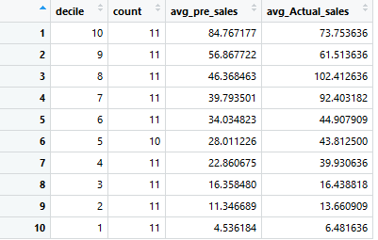

Deviated from Rank Order because of unusual observation

coefficients(fit3)

(Intercept) Price_in_thousands Engine_size Length Fuel_efficiency

-2.66527362 -0.05400917 0.23278893 0.02812158 0.09083145

Vehicle_typePassenger

-0.97813330

> confint(fit3, level=0.95)

2.5 % 97.5 %

(Intercept) -6.12338694 0.79283969

Price_in_thousands -0.07092900 -0.03708935

Engine_size -0.03733183 0.50290970

Length 0.01359504 0.04264813

Fuel_efficiency 0.02103082 0.16063208

Vehicle_typePassenger -1.46591298 -0.49035362

> coefficients(fit3) # model coefficients

(Intercept) Price_in_thousands Engine_size Length Fuel_efficiency

-2.66527362 -0.05400917 0.23278893 0.02812158 0.09083145

Vehicle_typePassenger

-0.97813330

> confint(fit3, level=0.95) # CIs for model parameters

2.5 % 97.5 %

(Intercept) -6.12338694 0.79283969

Price_in_thousands -0.07092900 -0.03708935

Engine_size -0.03733183 0.50290970

Length 0.01359504 0.04264813

Fuel_efficiency 0.02103082 0.16063208

Vehicle_typePassenger -1.46591298 -0.49035362

**Equation**:

**Y= B0+ B1X1 +B2X2+B3X3+B4X4+B5X5**

Sales_in_thousands = (-2.665274 +

Price_in_thousands* -0.054009+

Engine_size* 0.232789+

Length* 0.028122+

Fuel_efficiency*0.090831 +

Vehicle_typePassenger* -0.978133 )

**Diagnostic plots:**

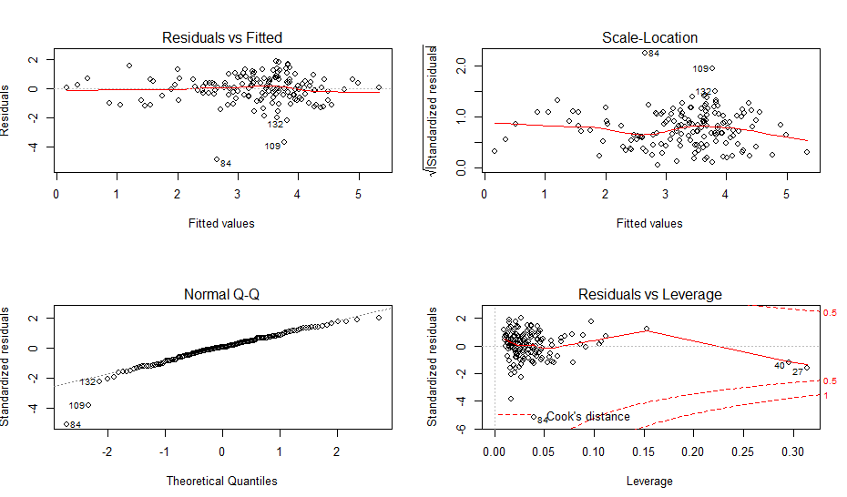

**Summary:**From the Significant values we can conclude that the value of Car Sales (Sales_in_thousands) is influenced by Price_in_thousands, Engine size, Length, Fuel efficiency, Vehicle type. Our Fit3 model will be a good multivariable regression model to predict the future car sales data set.